EXPERIMENT-11 DHILIPAN M
22/07/2026 192411038

MAP COLORING PROBLEM USING CONSTRAINT SATISFACTION PROBLEM (CSP)
AIM:
To write a Python program for solving the Map Colouring Problem using the Constraint Satisfaction Problem (CSP) approach.
ALGORITHM:
Step 1: Represent the map as a graph where each region is a node and neighboring regions are connected by edges.
Step 2: Define the available colors for each region.
Step 3: Assign colors to regions one by one using backtracking.
Step 4: Check whether the assigned color is different from the colors of all adjacent regions.
Step 5: If a conflict occurs, backtrack and try another color.
Step 6: Display the valid color assignment for all regions if a solution exists; otherwise, display "No Solution Found."
PROGRAM:
graph = {
'A': ['B', 'C'],
'B': ['A', 'C', 'D'],
'C': ['A', 'B', 'D'],
'D': ['B', 'C']
}
colors = ['Red', 'Green', 'Blue']
result = {}
def is_safe(node, color):
for neighbor in graph[node]:
if neighbor in result and result[neighbor] == color:
return False
return True
def solve(nodes, index):
if index == len(nodes):
return True
node = nodes[index]
for color in colors:
if is_safe(node, color):
result[node] = color
if solve(nodes, index + 1):
return True
del result[node]
return False
nodes = list(graph.keys())
if solve(nodes, 0):
print("Solution Found")
for node in nodes:
print(node, "->", result[node])
else:
print("No Solution Found")

OUTPUT:
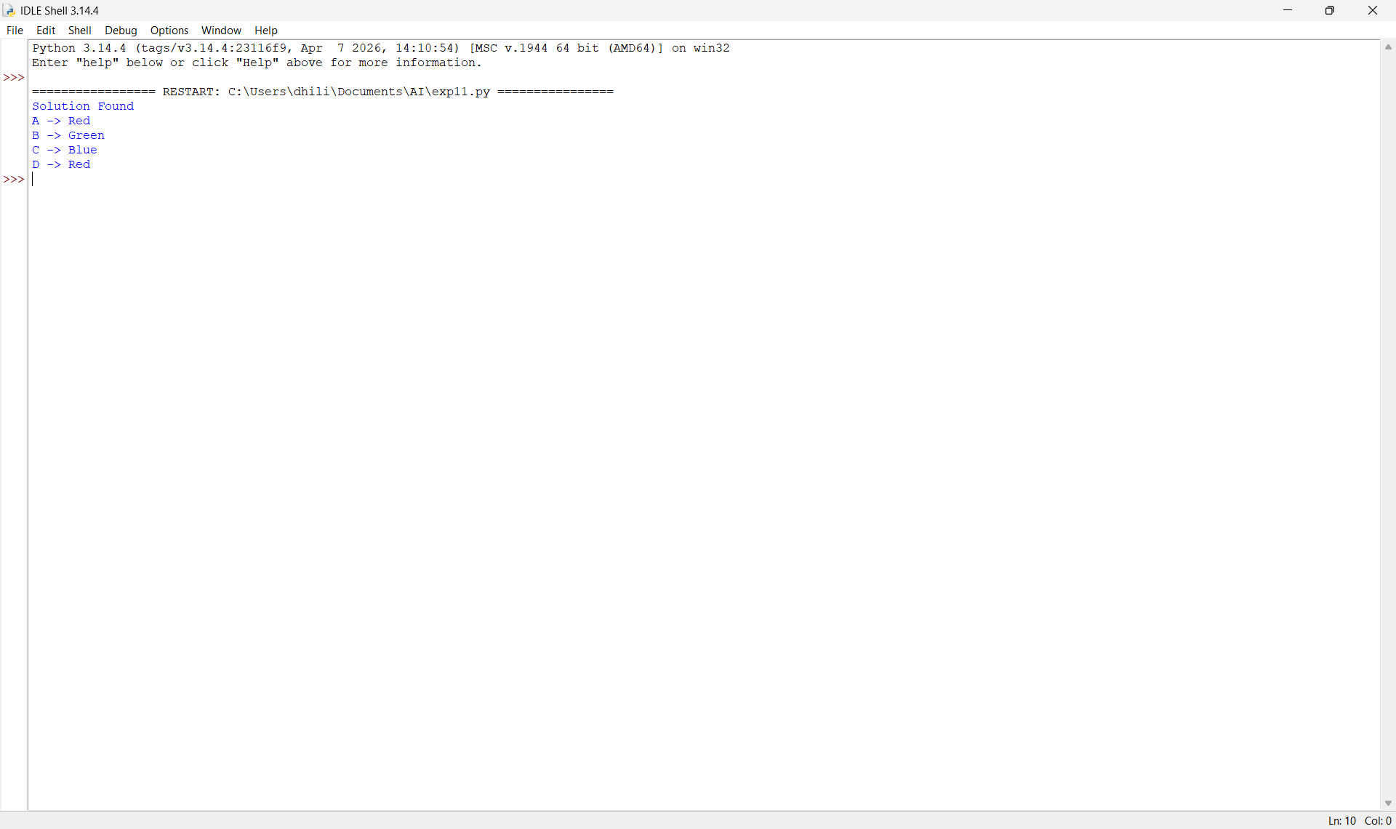

RESULT:
Thus, the Python program to solve the Map Colouring Problem using the Constraint Satisfaction Problem (CSP) approach was implemented successfully and the required output was obtained.

